**PROJECT REPORT**

**On**

**ONLINE CODE EDITOR**

*Submitted to*

*Centurion University of Technology& Management*

*in partial fulfillment of the requirement for award of the degree of*

B. TECH.

in

COMPUTER SCIENCE & ENGINEERING

*Submitted by*

*Rasid Khan (200301120085) Saurabh Kumar (200301120086)*

*Anand Singh (200301120031)*

***Under the Guidance of***

PROF. Rakesh Ku. Ray



**DEPT. OF COMPUTER SCIENCE & ENGINEERING**

# SCHOOL OF ENGINEERING &TECHNOLOGY, CUTM, Odisha

**May 2021**

CERTIFICATE

**This is to be certified that the project entitled “**ONLINE CODE EDITOR**” has been submitted for the Bachelor of Technology in Computer Science Engineering, School of Engineering &Technology, CUTM, Jatni during the academic year 2022-2023 is a persuasive piece of project work carried out by “** RASID KHAN, SAURABH KUMAR , ANAND SINGH**” towards the partial fulfillment for award of the degree (B.Tech.) under the guidance of “** Prof. RAKESH KU. RAY**” and no part there has been submitted by them for any degree to the best of my knowledge.**

**Signature of HOD Signature of Project Guide**

Prof. RAJ KU. MOHANTA Prof. RAKESH KU. RAY

**Signature of Coordinator Signature of Dean, SOET**

Prof. RAKESH KU. RAY Prof. (Dr.) Sujata Chakravarty

**EVALUATION SHEET**

**Title of the Project:** ONLINE CODE EDITOR

1. **Year of submission:2023**
2. **Name of the degree: BTech**
3. **Date of Examination: April 2023**
4. **Student Name with Regn No**.: 200301120085, 200301120086, 200301120031
5. **Name of the Guide:** Prof. RAKESH KU. RAY
6. **Result: [APPROVED/REJECTED]**

**Signature of Project Guide Signature of HOD**

Prof. RAKESH KU. RAY Prof. RAJ KU. MOHANTA

**Signature of Coordinator Signature of Dean, SOET**

Prof. RAKESH KU. RAY Prof. (Dr.) Sujata Chakravarty

CANDIDATE’ S DECLARATION

**We,** Rasid Khan, Saurabh Kumar & Anand Singh**, B.Tech in CSE (Semester- 6) of School of Engineering & Technology, CUTM, Jatni, hereby declare that the Project Report entitled “**ONLINE CODE EDITOR**” is an original work and data provided in the study is authentic one. This report has not been submitted to any other Institute for the award of any other degree by me.**

Signature of Student

RASID KHAN

SAURABH KUMAR

ANAND SINGH

Place: Bhubaneswar Date:

**ACKNOWLEDGEMENT**

**It is my pleasure to be indebted to various people, who directly or indirectly contributed in the development of this work and who influenced my thinking, behavior and acts during the course of study.**

**We express my sincere gratitude to ** **, Dean, SOET for providing academic support &opportunities.**



**We extend my sincere appreciation to** Prof. RAKESH KU. RAY **Supervisor who provided hir valuable suggestions and precious time in accomplishing my project report.**

**We again extend my sincere appreciation to** Prof. RAJ KU. MOHANTA **HoD who provided hir valuable suggestions and precious time in accomplishing my project report.**

**We also extend my sincere appreciation to** Prof. RAKESH KU. RAY **Coordinator who provided her valuable suggestions and precious time in accomplishing my project report.**

**Lastly, We would like to thank the almighty and my parents for their moral support and friends with whom I shared my day-to day experiences and received lots of suggestions those improved the quality of work.**

## **ABSTRACT**

An online code editor is a web-based application that enables developers and programmers to write, edit, and run code directly from a web browser. This technology has gained immense popularity due to its convenience, accessibility, and collaborative features. The purpose of this abstract is to provide a concise overview of an online code editor, its functionalities, advantages, and impact on the development community.

The online code editor offers a user-friendly interface with syntax highlighting, auto-completion, and debugging features, empowering developers to write code efficiently and with reduced errors. It supports multiple programming languages, allowing programmers to work on various projects within a single platform. The real-time collaboration feature facilitates team collaboration by enabling developers to edit and review code simultaneously, enhancing productivity and fostering knowledge-sharing among team members.

## **CONTENTS**

1. **INTRODUCTION**
2. **OBJECTIVE**
3. **SYSTEM REQUIREMENTS**
4. **IMPLEMENTATION DETAILS**
5. **SOURCE CODE AND RESULTS**
6. **CONCLUSION**

## **INTRODUCTION**

**I**n the fast-paced world of software development, the demand for efficient and collaborative coding tools has never been greater. With the rise of remote work and geographically dispersed teams, developers require a solution that allows them to write, edit, and run code seamlessly from anywhere in the world. This is where the online code editor emerges as a game-changing innovation, transforming the way developers approach their work and interact with their coding projects.

An online code editor is a web-based application that provides a comprehensive coding environment accessible through a standard web browser. It offers a wide range of programming language support, equipped with powerful features such as syntax highlighting, auto-completion, and error detection, which significantly enhance code writing productivity and accuracy. Whether a seasoned developer or a coding enthusiast, an online code editor caters to the needs of all skill levels, making it an inclusive and indispensable tool for the modern development community.

The advantages of an online code editor extend beyond collaboration. Cloud-based storage and integration with version control systems ensure that developers' code is securely stored and easily accessible across devices. This eliminates the need for complex setup processes and allows developers to pick up their work seamlessly from any location with an internet connection.

As the technology continues to evolve, the online code editor is poised to become an indispensable companion for developers, enabling them to write, share, and collaborate on code with unparalleled ease and efficiency.

## **OBJECTIVE**

The objective of the online code editor is to provide developers and programmers with a versatile, efficient, and collaborative coding platform accessible through a web browser. The primary goals of this innovative tool are as follows:

Accessibility and Convenience: The online code editor aims to offer developers the flexibility to write, edit, and run code from anywhere with internet access. By eliminating the need for local installations and supporting multiple devices, the objective is to empower developers to work on their projects seamlessly and efficiently, without being tied to a specific location or device.

Multilingual Support: The online code editor endeavors to support a wide array of programming languages, catering to the diverse needs of developers. The objective is to enable programmers to work on projects in their preferred language, fostering productivity and accommodating a variety of software development tasks.

Enhanced Productivity: Through features such as syntax highlighting, auto-completion, and error detection, the online code editor seeks to boost developer productivity by reducing manual effort and identifying coding errors in real-time. The objective is to create a coding environment that helps developers write clean, efficient code with fewer mistakes.

In summary, the objective of the online code editor is to empower developers with a robust, feature-rich, and collaborative coding environment that transcends geographical boundaries, facilitates efficient teamwork, and elevates the overall software development process. By meeting these objectives, the online code editor seeks to become an indispensable tool for developers worldwide, fostering a vibrant and thriving coding community.

## **SYSTEM REQUIREMENTS**

Hardware Requirement

1. Operating System (64 bytes)
2. RAM (8 Gb and Above)
3. Processor 10th Gen Intel

Software Requirements

1. Operating System - Windows
2. Technology - HTML, CSS, JavaScript, React, Node Js, MySQL
3. Tools – VS Code
4. Browser - Google Chrome

IMPLEMENTATION DETAILS

## **HTML**

HTML is the backbone of an online code editor, providing the foundation for its user interface and layout.

It structures the editor's components, such as the code input area, toolbar, and collaboration features.

HTML elements define the editor's functionality, enabling users to interact with code and execute actions.

Additionally, HTML integrates with other web technologies like CSS and JavaScript to enhance the editor's visual appeal and functionality.

## **CSS**

In an online code editor, CSS is used to style and format the user interface, providing an appealing and intuitive environment for developers.

It enables the customization of fonts, colors, layouts, and themes, making the editor visually engaging and easy to use.

Additionally, CSS ensures that the code editor's interface is responsive, adapting seamlessly to various screen sizes and devices, promoting a seamless coding experience.

JAVASCRIPT

JavaScript is a key component of online code editors. It executes client-side scripts, enabling interactive functionalities.

Developers use JavaScript to handle user interactions, perform real-time code validation, and implement features like syntax highlighting and auto-completion.

Its versatility allows for dynamic manipulation of the DOM, facilitating live updates of the code editor interface.

Additionally, JavaScript interacts with backend APIs to save and retrieve code, facilitating seamless collaboration and storage of projects.

## **REACT**

React, a popular JavaScript library, enhances the user interface and user experience in online code editors.

Utilizing its component-based architecture, developers create reusable UI elements, improving code editor modularity and maintainability.

React's virtual DOM efficiently updates the UI, optimizing performance. In online code editors, React powers live previews and real-time code rendering, enabling developers to see changes instantly.

Its declarative approach simplifies state management and ensures consistent and responsive user interactions.

NODE JS

In the project, Node.js is implemented as the server-side runtime environment.

It leverages its non-blocking, event-driven architecture to handle concurrent connections efficiently.

Node.js processes incoming requests, executes server-side scripts, and communicates with the online code editor's frontend.

Its asynchronous nature enables smooth real-time collaboration, allowing developers to write, edit, and run code seamlessly, making it an integral part of the online code editor's backend infrastructure.

## **MySQL**

In the project, MySQL is implemented as the relational database management system (RDBMS) to store and manage data.

It is integrated using its native JDBC driver, allowing Java applications to establish connections and execute SQL queries.

MySQL provides a robust and efficient database solution, ensuring data persistence and accessibility for the online code editor's collaborative and storage features.

# **SOURCE CODE**

CodeEditorWindow.js

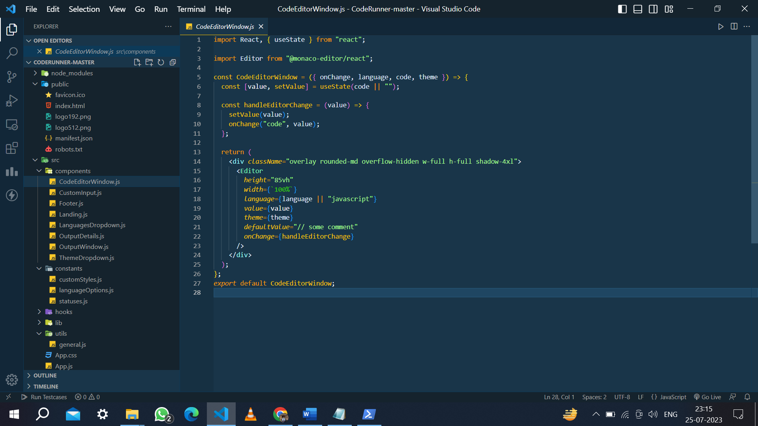

CustomInput.js

## 

**Footer.js**

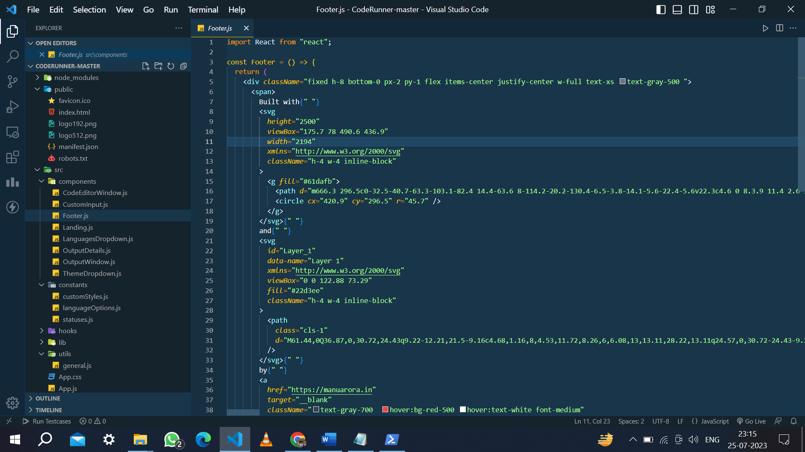

## **Loading.js**

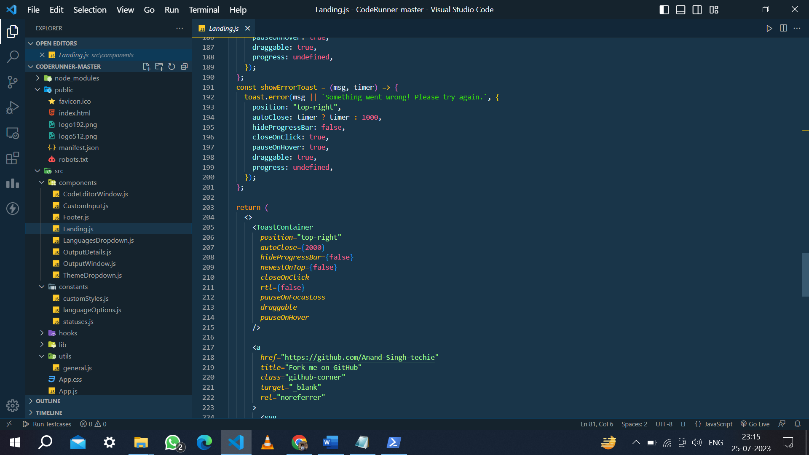

**LanguageDowndrop.js**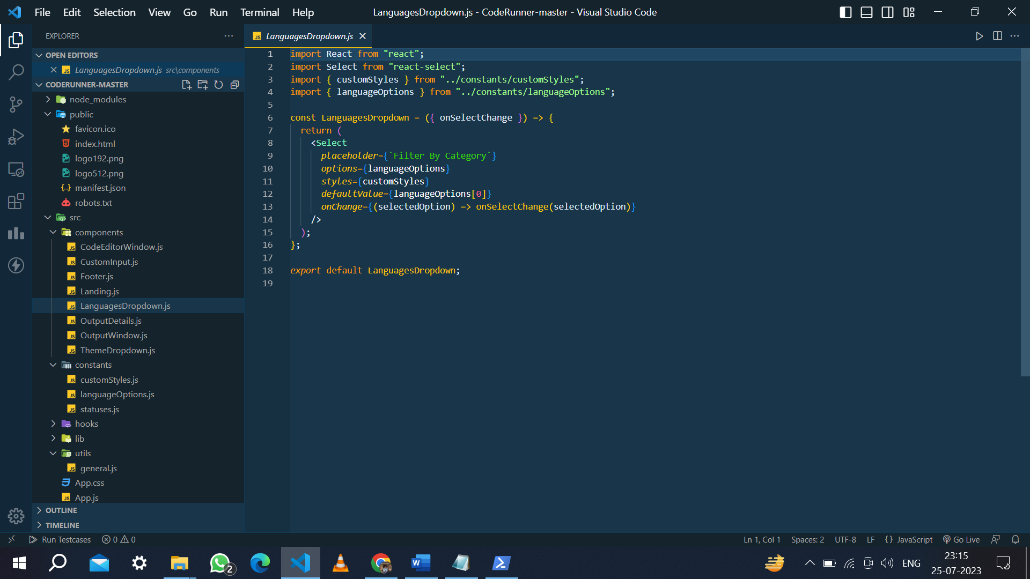

## **OutputDetails.js**

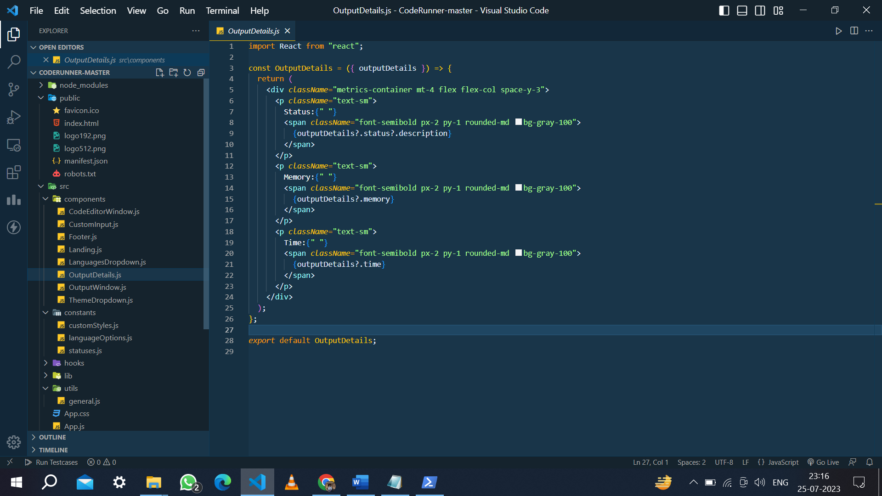

**OutputWindow.js**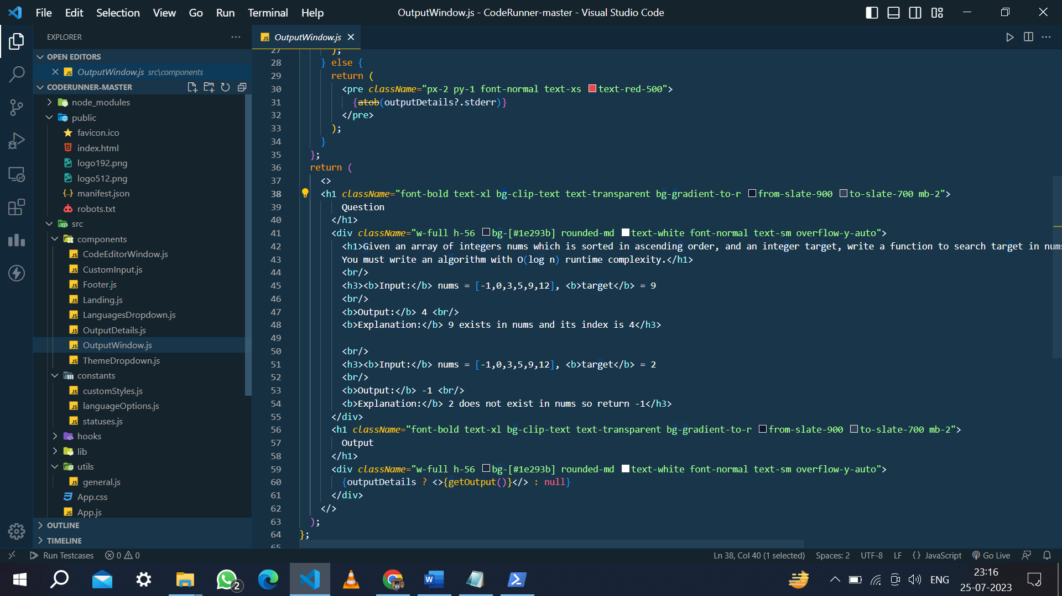

**ThemeDropdown.js**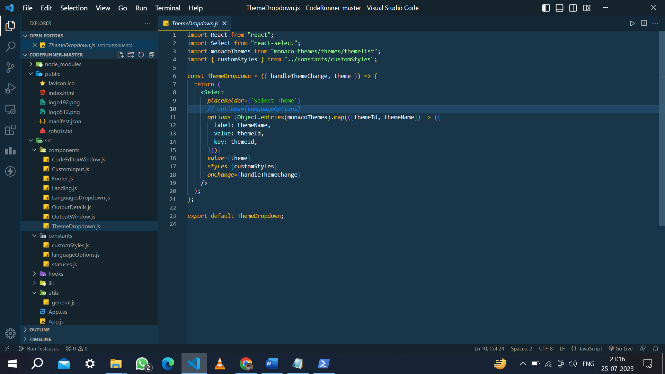

# **RESULT**

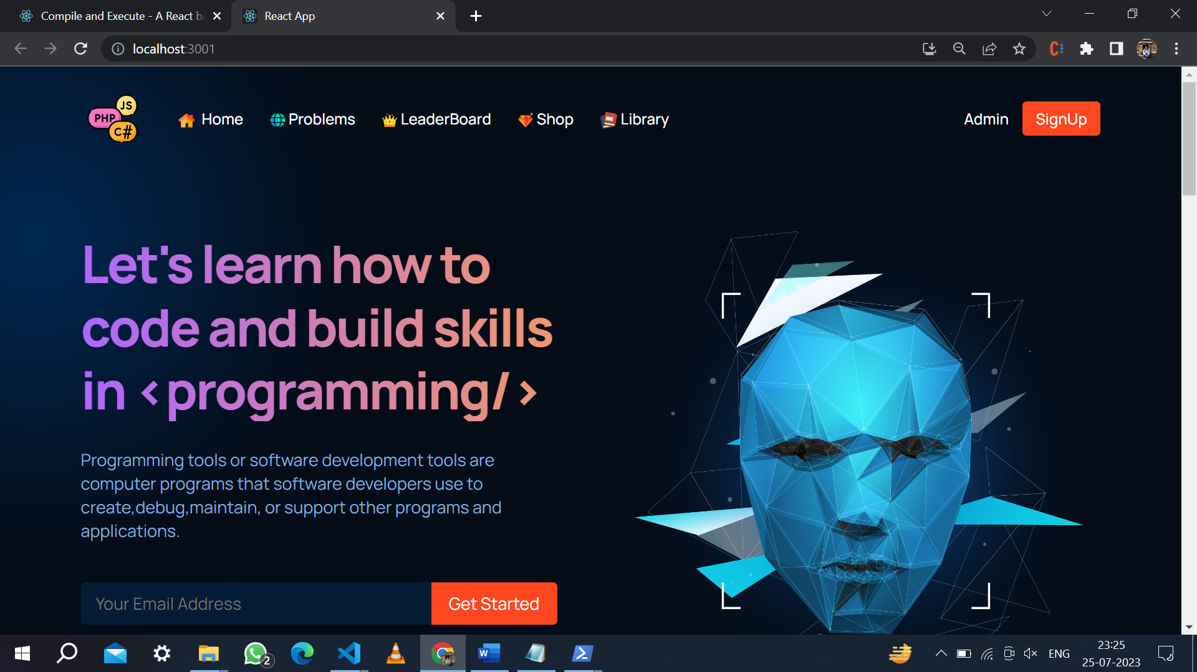

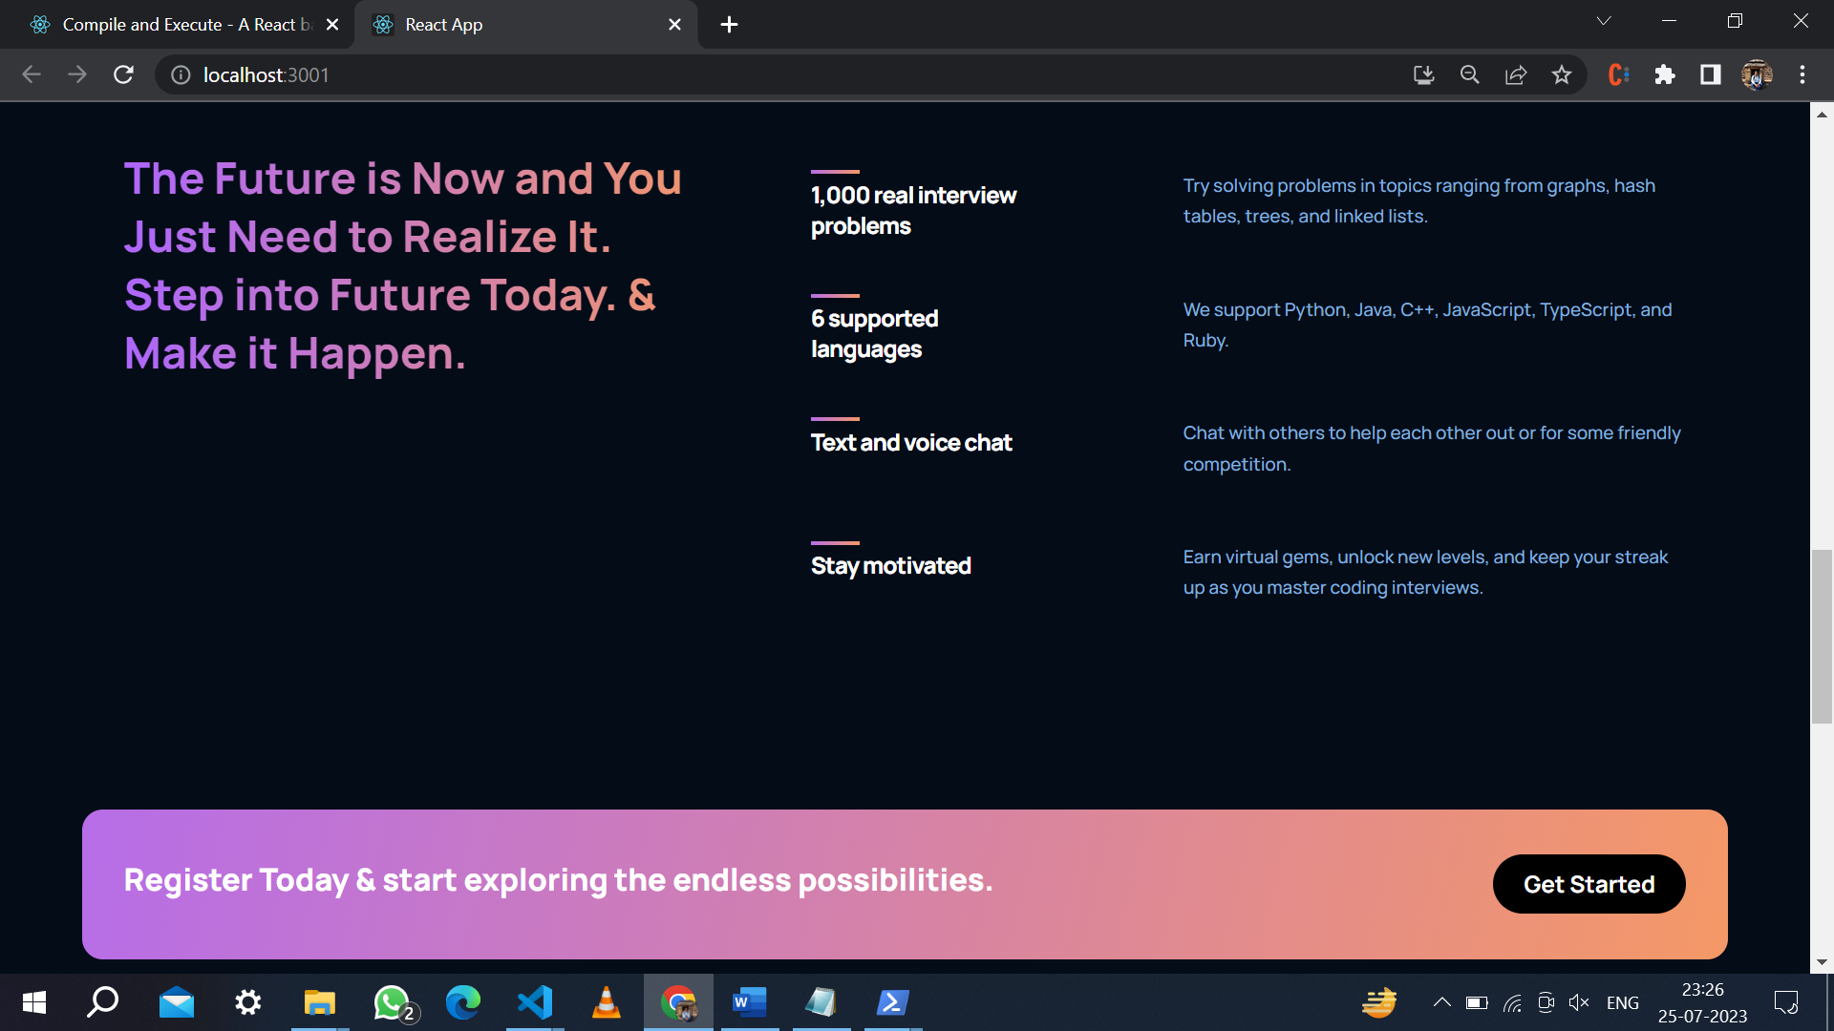

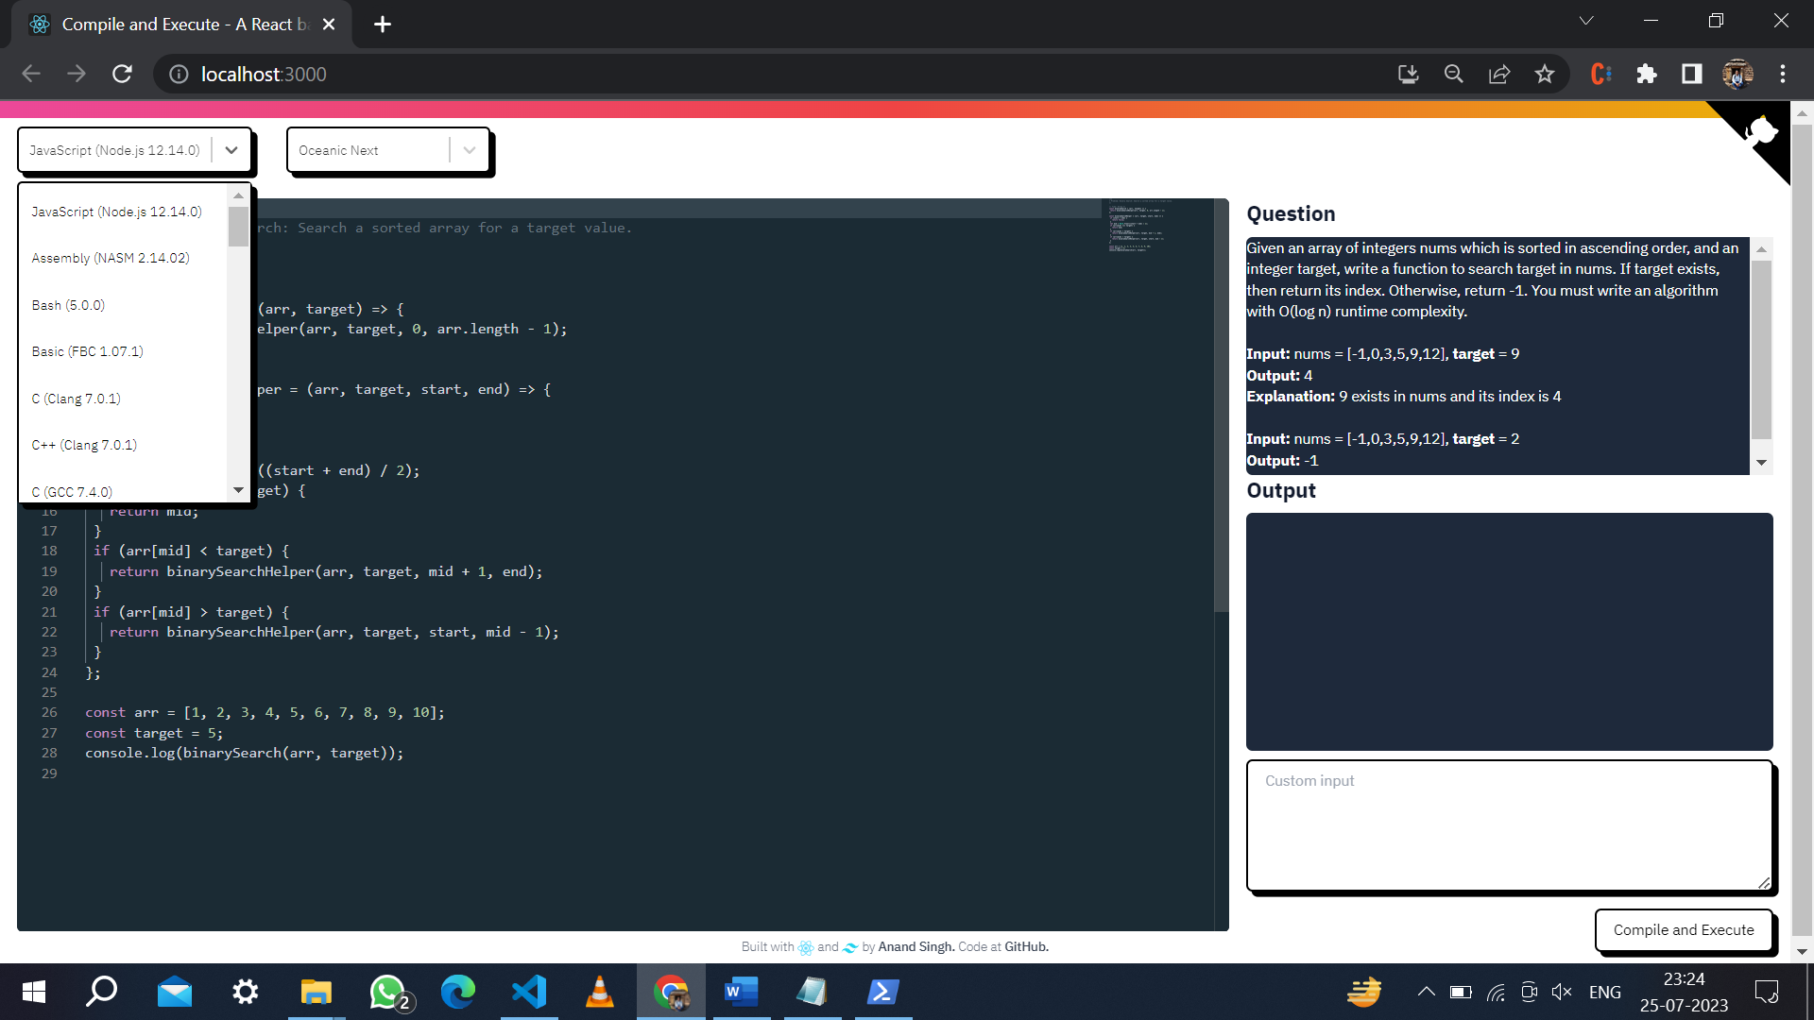

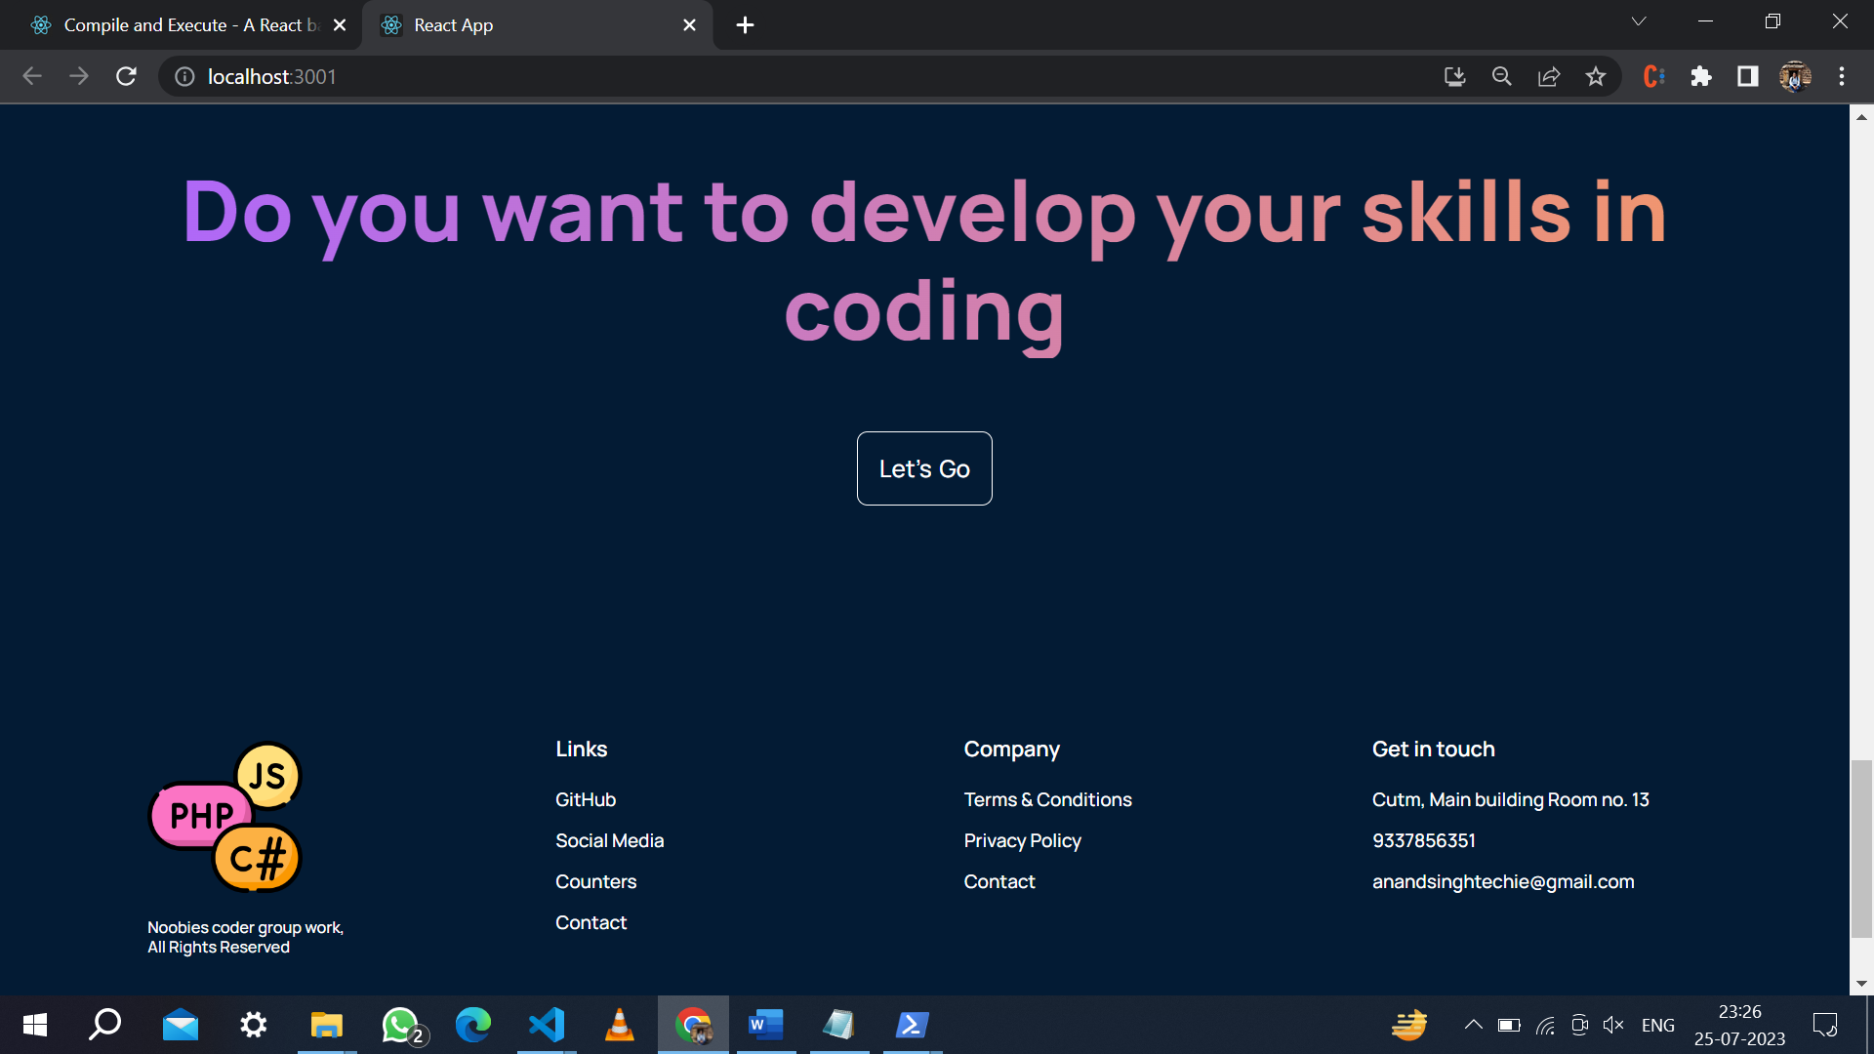

## **CONCLUSION**

In conclusion, the online code editor stands as a pivotal tool revolutionizing the landscape of software development.

Its accessibility, convenience, and support for multiple programming languages empower developers to write, edit, and collaborate on code seamlessly from anywhere.

Real-time collaboration capabilities foster teamwork and knowledge-sharing among developers, resulting in increased productivity and efficient development cycles. With its secure environment, cloud-based storage, and integration with version control systems, the online code editor ensures data integrity and accessibility.

Moreover, the incorporation of JavaScript and React elevates the user experience, making it a versatile and indispensable platform for modern coding endeavors.

As technology continues to evolve, the online code editor is poised to remain a cornerstone of software development, driving innovation and efficiency in the digital era.